**LCD Module Description Document**

**1.  LCD Controller Introduction**

The relationship between the LCD Controller (hereinafter referred to as LCDC) module and the external LCD Driver Chip is shown in Figure 1 below.

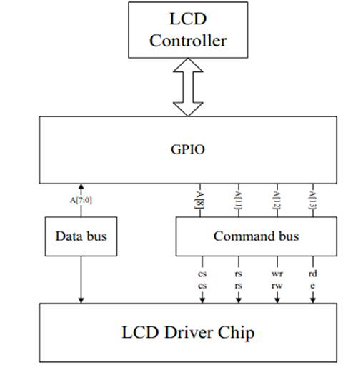

Figure 1 Connection Diagram of LCDC and LCD Driver Chip

The LCDC module's internal AHB bus can communicate with the external LCD driver according to the standard 8080/6800 bus protocol. The MCU can also directly control the 8080/6800 bus. The module integrates a 16*32-bit RF memory as a data buffer. The output to the LCD 8080/6800 parallel data bus is 8 bits wide.

The module clock is 96M, affected by system frequency reduction.

Table 1: Correspondence of LCDC pins

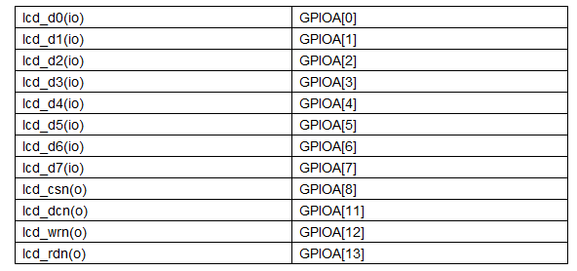

1. **LCD Controller Module Instructions for Use**

LCDC read/write data reference Figure 2:

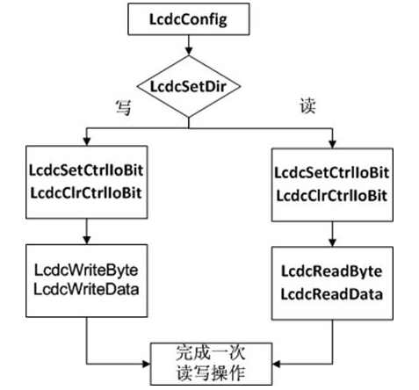

Figure 2 LCDC read/write diagram

Translation:

写=Write

读=Read

完成一次读写操作=Complete a read/write operation